1.nmap 192.168.1.1-Scan common ports
Purpose: To scan the target device (192.168.1.1) for common TCP ports and identify which ports are open, closed, or filtered.
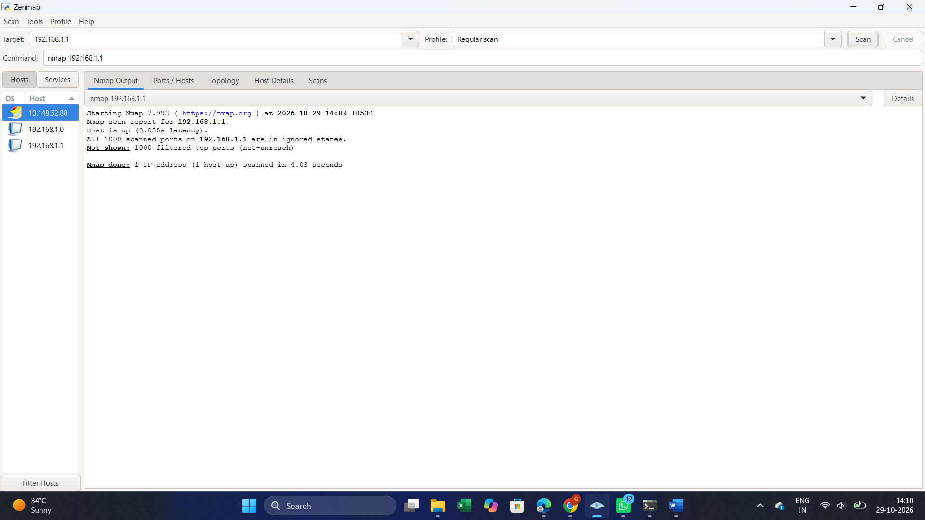
2.nmap -sn 192.168.1.0/24-Discover live hosts
Purpose: To identify all active devices connected to the local network (192.168.1.0/24) without scanning their ports, helping administrators understand which hosts are currently reachable on the network.
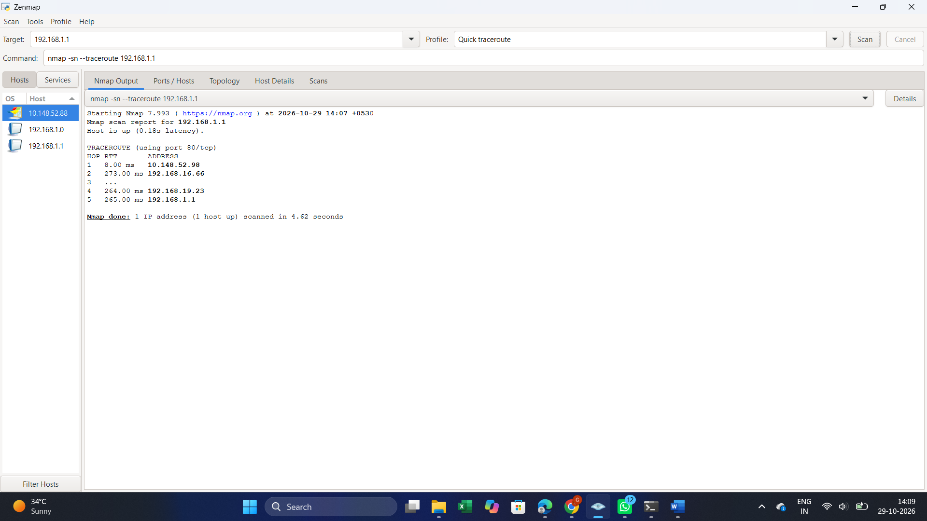

3.nmap -sV 192.168.1.1-Detect service versions
Purpose: To detect the services running on the target device (192.168.1.1) and identify their version numbers. This helps administrators identify outdated software and potential security vulnerabilities so they can take appropriate security measures.
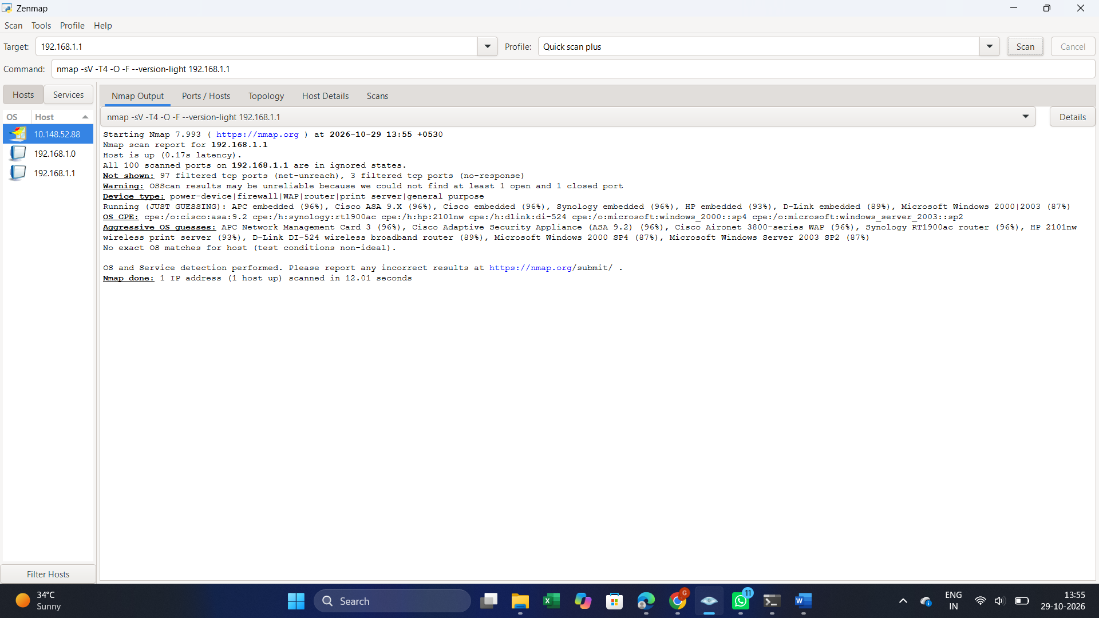

4.nmap -O 192.168.1.1-Identify the operating system
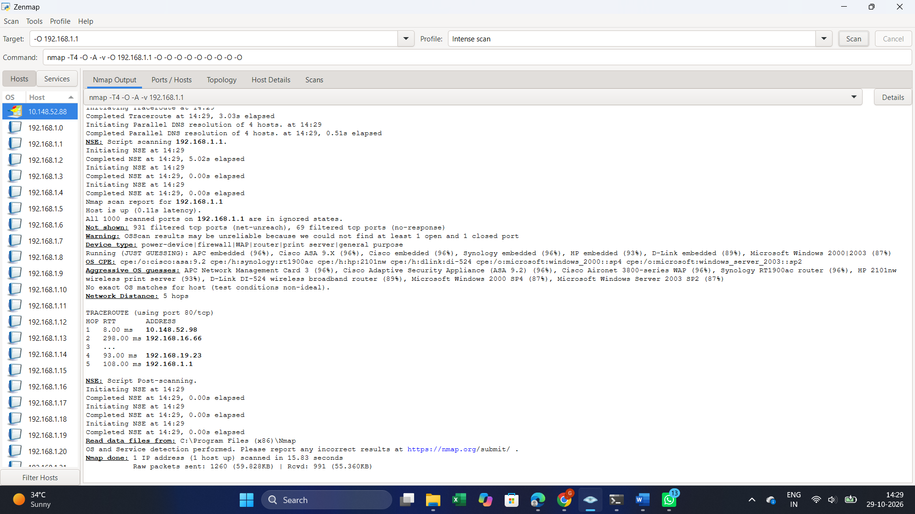
5.nmap -p 80,443 192.168.1.1 Scan specific ports
Purpose: To identify the operating system running on the target device (192.168.1.1) using Nmap OS detection techniques. This helps network administrators understand the target system and assess potential security risks based on its operating system.

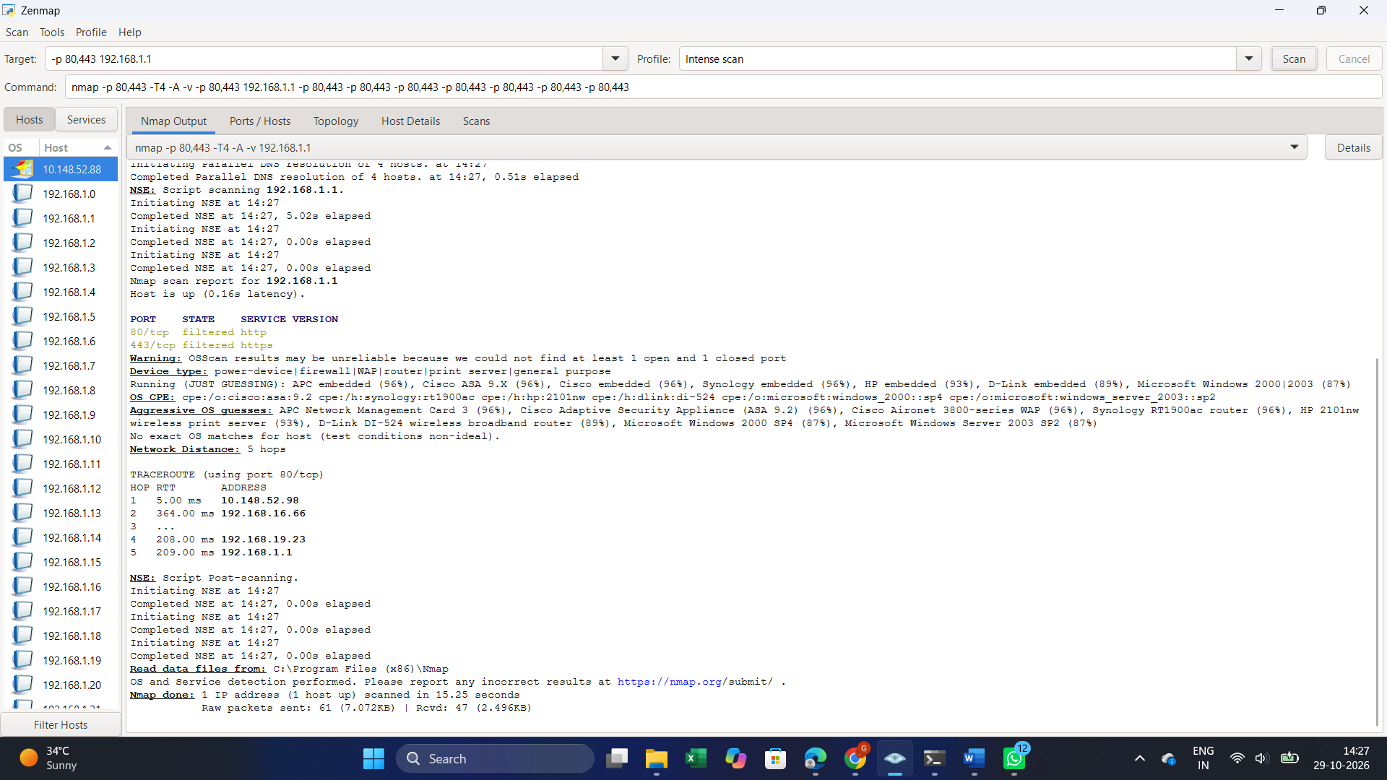
6.nmap -sC 192.168.1.1 Run default NSE scripts
Purpose: To run Nmap's default Network Scripting Engine (NSE) scripts against the target device (192.168.1.1) to gather additional information about open ports, running services, and potential security issues. This helps network administrators identify possible misconfigurations and security risks.
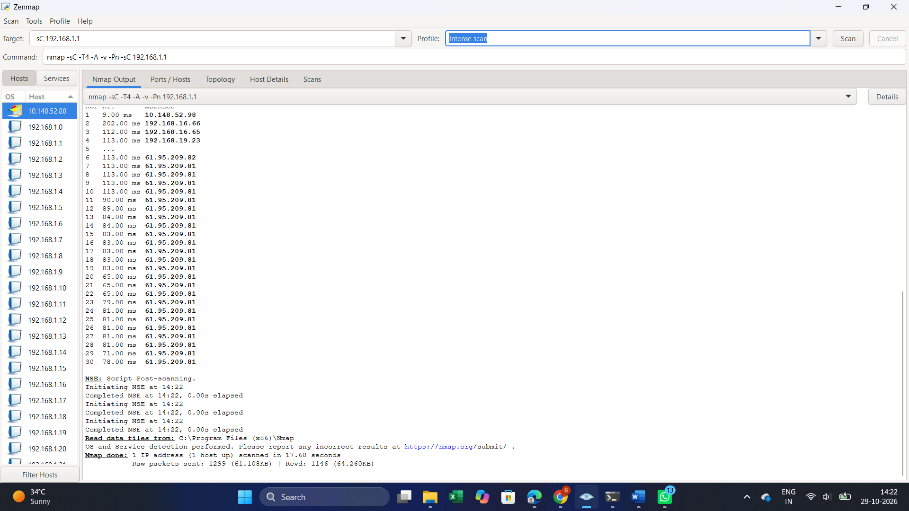
7.nmap -Pn 192.168.1.1 Skip host discovery
Purpose: To skip the host discovery process and scan the target device (192.168.1.1) directly, even if Nmap cannot confirm that the host is active. This is useful when a device blocks host discovery probes but may still respond to port-scanning requests.

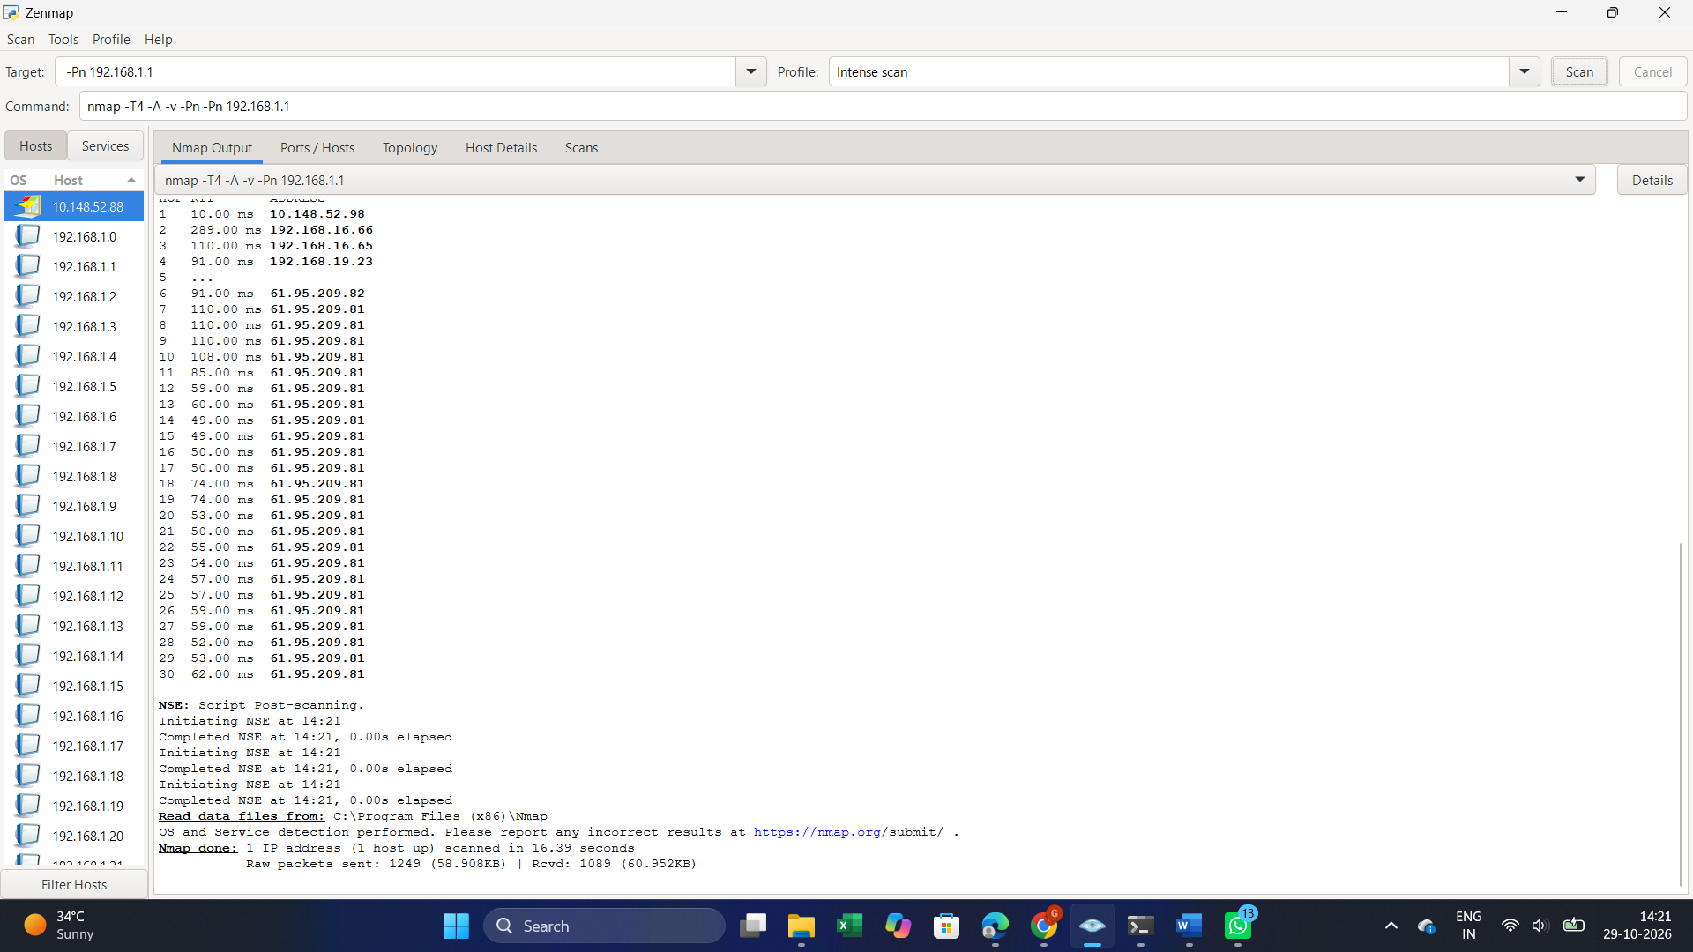
8.-oN scan.txt 192.168.1.1 Save scan results to a file
Purpose: To save the Nmap scan results of the target device (192.168.1.1) into a text file named scan.txt. This helps network administrators maintain scan records, review open ports and services later, and document security assessment findings.

